Week 3 class exercise

Class example

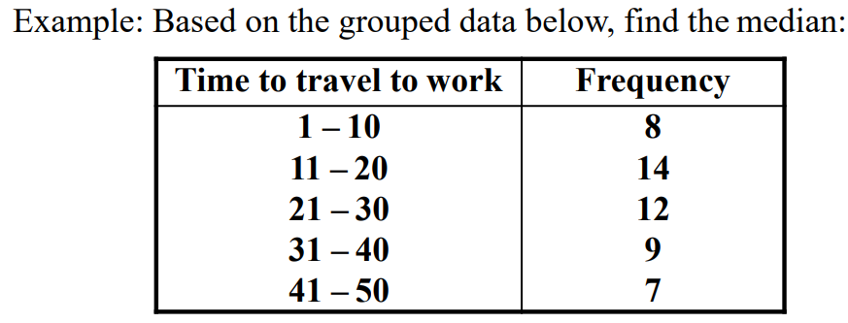

**Study the table below show the height of various students in a class**

|  |  |
| --- | --- |
| Height (cm) | Frequency |
| 150 – 154 | 5 |
| 155 – 159 | 2 |
| 160 – 164 | 6 |
| 165 – 169 | 8 |
| 170 – 174 | 9 |
| 175 – 179 | 11 |
| 180 – 184 | 6 |
| 185-189 | 3 |

Question 1.

Calculate the following measures in below dataset

1. Mean
2. Median
3. Mode
4. Interquartile range
5. Variance
6. Standard deviation

